The Anglican Chaplaincy in Norway
invites you to a service of
CHORAL EVENSONG
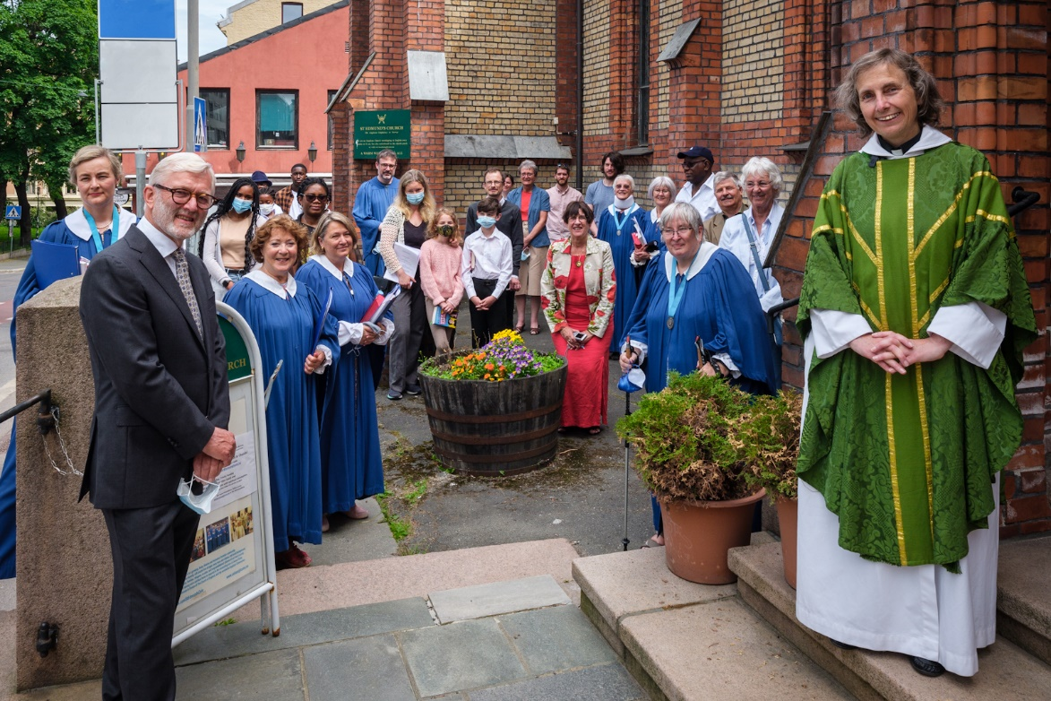
on Sunday 20th June 2021 at 1800
at St Edmund’s Church, Oslo
Services of Holy Communion continue every Sunday at 1100. All are welcome
For each service there will be a maximum of 50 places for the congregation which may be booked in advance by email to forstander@osloanglicans.no.
Bookings should be received by 12 Noon the previous day.
Please do not attend if you are unwell or have any COVID 19 symptoms. Measures of safe distancing, face-masks and cleaning are also in place. See www.osloanglicans.no

